For Immediate Release: Thursday, Feb. 6, 2020

Contact: Christina Johnson, [christina@on3pr.com](mailto:christina@on3pr.com), 850.391.5040

**Florida Patient Protection Coalition formed to combat misinformation  
regarding the level of education, training between physicians and mid-level practitioners**

(Tallahassee, Fla.) – More than 50 County Medical and Specialty Societies across the state today announced the formation of the [Florida Patient Protection Coalition](https://www.floridapatient.com/) (FPPC) to educate the public on the benefits of physician-led, team-based care and to combat the false and vitriolic narrative spun by supporters of [House Bill 607](https://www.myfloridahouse.gov/Sections/Bills/billsdetail.aspx?BillId=67729&SessionId=89) related to health care practitioners.

“The Florida Patient Protection Coalition seeks to counter the propaganda being disseminated by the nursing and physician assistant groups pushing for independent practice legislation,” said **FMA President Ronald F. Giffler, MD, JD, MBA.** “The Florida Medical Association believes that independent practice and team-based care take health care delivery in two very different directions. Independent practice further compartmentalizes and fragments health care delivery, while team-based care fosters greater integration and coordination.”

There are vast differences in the education and training of physicians compared to that of non-physician health care practitioners. A Medical Doctor must complete four years of medical school followed by three or more years of graduate medical education, which includes at least 15,000 clinical training hours (see graphic below).

In contrast, advanced nursing degree programs only recommend 500 post-baccalaureate hours (about 12 weeks) of clinical training for Masters of Science in Nursing degrees and 1,000 post-baccalaureate hours of clinical training for Doctorate of Nursing Practice degrees. Advanced Practice Registered Nurses (APRNs) are not required to complete *any* training beyond graduate school, whereas Medical Doctors complete three to seven years of residency training in a select surgical or medical specialty under experienced physician faculty supervision.

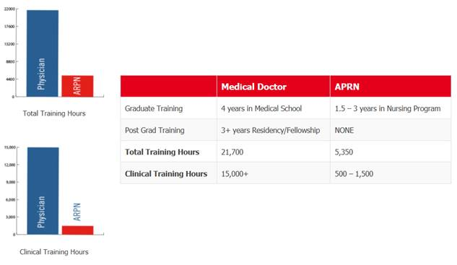

“As a member of the Florida Patient Protection Coalition, it is critical we push back on special interest groups who seek to compromise the quality of health care by allowing Advanced Practice Registered Nurses and Physician Assistants to practice beyond the scope of their education and training,” said **Christie Alexander, MD, President, Florida Chapter of the American Academy of Family Physicians.** “This coalition believes patients’ best interests are optimally served when they are treated in a physician-led, team-based model of care.”

Fast Facts:

* According to a 2013 study by the Mayo Clinic, inappropriate referrals to tertiary referral centers by APRNs and Physician Assistants (PAs) could offset any potential savings from the increased use of APRNs and PAs.
* A *JAMA Internal Medicine* study found that APRNs and PAs were associated with more ordered diagnostic imaging than primary care physicians.
* A brief report by the Infectious Diseases Society of America found that ambulatory visits involving APRNs and PAs more frequently resulted in an antibiotic prescription compared with physician visits.
* Physician supervision is the norm, not the exception:
  + States that do not allow APRNs to practice independently make up roughly 70% of the population.
  + 9 of the 10 most populous states do not allow APRNs to practice independently.

Across the country, patients overwhelmingly want a coordinated approach to health care, with a physician leading the health care team. Key findings from AMA 2012 and 2018 surveys include:

* **Ninety-one percent (91%)** of respondents said that a physician’s years of education and training are vital to optimal patient care, especially in the event of a complication or medical emergency.
* **Eighty-six percent (86%)** of respondents said that patients with one or more chronic conditions benefit when a physician leads the primary health care team.
* **Eighty-four percent (84%)** of respondents said that they prefer a physician to have primary responsibility for the diagnosis and management of their health care.

**About the Florida Patient Protection Coalition (FPPC)**

Joined by more than 50 state medical professional societies, the FMA has launched the Florida Patient Protection Coalition to educate the public about a dangerous legislative proposal, HB 607, which would allow Advanced Practice Registered Nurses (APRNs) and Physician Assistants (PAs) to practice independently without any supervision from licensed physicians.

The coalition’s new website, [www.floridapatient.com](http://www.floridapatient.com), also explains the importance of physician-led, team-based care while highlighting the vast difference in physicians’ education and training compared to that of nurse practitioners and PAs. This collaborative effort shows that Florida’s medical community is unified in protecting patients, and it also counters the propaganda from special interest groups that are urging state lawmakers to pass independent practice legislation.

**Listing of Florida Patient Protection Coalition members**

Alachua County Medical Society

Bones Society of Florida

Brevard County Medical Society

Broward County Medical Association

Capital Medical Society

Charlotte County Medical Society, Inc.

Clay County Medical Society

Collier County Medical Society

Dade County Medical Association

Duval County Medical Society

Emerald Coast Medical Society

Escambia/Santa Rosa County Medical Society

Female Indian Physicians of South Florida

Florida Academy of Family Physicians

Florida Academy of Pain Medicine

Florida Chapter – American Academy of Pediatrics, Inc.

Florida Chapter American College of Physicians

Florida Chapter American College of Surgeon

Florida Chapter Division of the American Academy of Emergency Medicine

Florida Chapter, American College of Cardiology

Florida College of Emergency Physicians

Florida Medical Association

Florida Orthopaedic Society

Florida Osteopathic Medical Association

Florida Psychiatric Society

Florida Pulmonary Society

Florida Radiological Society

Florida Society of Anesthesiologists

Florida Society of Dermatology and Dermatologic Surgery

Florida Society of Nephrology

Florida Society of Neurology

Florida Society of Ophthalmology

Florida Society of Pathologists

Florida Society of Physical Medicine & Rehabilitation

Florida Society of Rheumatology

Florida Society of Thoracic & Cardiovascular Surgeons

Florida Urological Society

Florida Vascular Society

Hillsborough County Medical Association, Inc.

Indian Physicians of South Florida

Lake-Sumter Medical Society

Lee County Medical Society

Manatee County Medical Society

Marion County Medical Society

Palm Beach Medical Society

Physician Society of Central Florida

Pinellas County Medical Association

Polk County Medical Society

Sarasota County Medical Society

# # #

**Editor’s Note:**

Three additional members were named to the coalition after the release was sent on Thurs., Feb. 6. They include the Florida Allergy, Asthma & Immunology Society, Indian River County Medical Society and the Volusia County Medical Society.