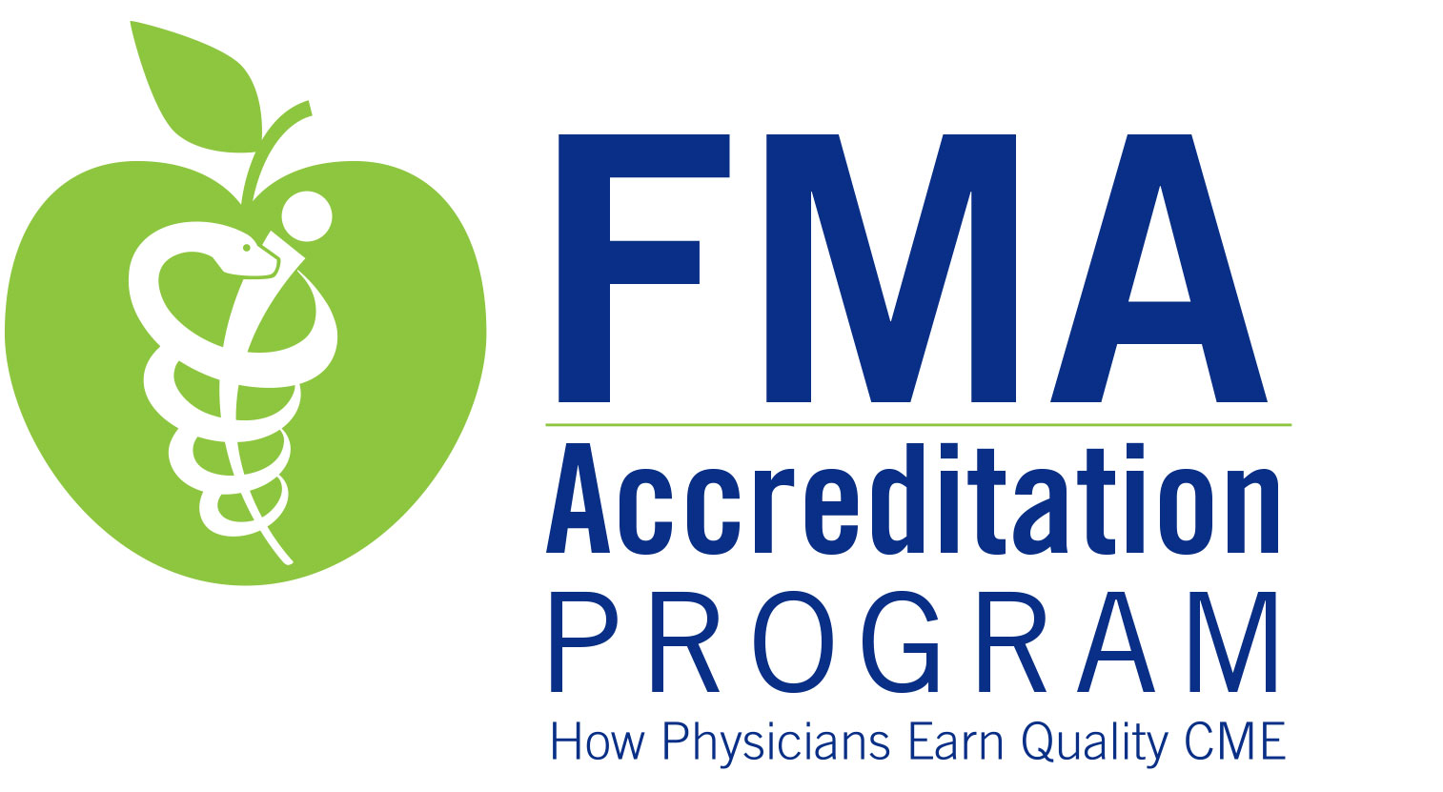

Pre-Application for FMA Accreditation

Eligibility Information &
Demonstration of Mechanisms
to fulfill
FMA Accreditation Requirements
Overview of the Pre-Application for FMA Accreditation

Thank you for requesting an FMA Pre-Application. The FMA looks forward to supporting your efforts to become an FMA-accredited continuing medical education (CME) provider.

Purpose of Accreditation
Accreditation is a mark of quality CME activities that are planned, implemented and evaluated by accredited providers in accordance with Accreditation Criteria, Standards for Commercial Support, and policies. Accreditation assures the medical community and the public that such activities provide physicians with information that can assist them in maintaining or improving their practice of medicine, to help them bridge the gap between today’s care and what care should be. In addition, accredited CME activities are free of commercial bias and based on valid content.

The ACCME and FMA
The Accreditation Council for Continuing Medical Education (ACCME) is the organization that sets educational standards and policies for CME activities. ACCME accredits organizations that serve a national target audience of physicians and recognizes state medical societies as accrediting partners within the states that choose to operate as accreditors. If more than 30% of the physician target audience in your proposed CME Program comes from outside Florida and its contiguous states, or if your organization is an LCME-accredited school of medicine, contact the ACCME for national accreditation.

FMA is recognized by the ACCME as an accreditor of CME providers in Florida. FMA’s system of accreditation is equivalent to that of the ACCME’s national system of accreditation; therefore, you will see some references to ACCME policies, especially in the Standards for Commercial Support, which are trademarked by the ACCME. Additional information about the ACCME, headquartered in Chicago, IL, can be found at www.accme.org.

FMA’s Expectations
- For initial applicants, the accreditation process generally takes twelve to eighteen months. Eligible organizations that decide to apply for FMA accreditation should be prepared to both describe and furnish evidence that demonstrates compliance with the accreditation requirements, therefore, organizations must plan, implement and evaluate at least three CME activities (10-15 credits) within the 12-month period prior to the submission of the Self-Study Report, one of these activities should be implemented prior to the submission of the Pre-Application, and used as the example in the Pre-Application. These two activities should be offered in joint providership with an accredited organization (FMA or an ACCME- or FMA-accredited provider).

- FMA expects its accredited providers to monitor their overall CME program on a regular basis for compliance with the accreditation requirements and to fulfill annual reporting requirements.

- Payment of certain fees is required to obtain and maintain FMA accreditation. Standard accreditation fees and other types of fees are provided in the FMA Accreditation Manual. The manual can be accessed at www.flmedical.org.

Eligibility to Apply for FMA Accreditation
To qualify for eligibility, an organization must demonstrate that it meets the following criteria:
- Be located in Florida
- Is not a “commercial interest” which is defined as “any entity producing, marketing, reselling, or distributing healthcare goods or services used on or consumed by patients”
- Offers CME activities for physicians on a regular and recurring basis
- Presents activities that have “valid” content, that which promotes recommendations, treatment or manners of practicing medicine that fall within the definition of CME (may not present activities that promote treatments that are known to pose risks or dangers that outweigh the benefits or are known to be ineffective in the treatment of patients
- Serves a target audience with no more than 30% of physician learners from beyond Florida and its bordering states of Georgia and Alabama.
- Demonstrates an overall organizational commitment to the CME program, including physician leadership, adequate financial support, appropriate staffing, and record-keeping capabilities
- Demonstrates the capacity to comply with all FMA accreditation requirements and policies

When there is a question regarding eligibility, FMA reserves the right to make decisions on the issue.

Pre-Application Process
The first step in becoming accredited is completion/submission of the Pre-Application for FMA Accreditation and submission of a non-refundable $250 pre-application fee.

The purpose of the Pre-Application is to provide you with an opportunity to explain your eligibility for FMA accreditation, as well as to demonstrate that your organization has mechanisms in place to fulfill FMA’s accreditation requirements in the CME activities that you are producing or have produced, and to attach examples to verify your descriptions. This verification must come from activities that have occurred within the 12 months that proceed the date this Pre-Application form is received.

Once your organization has submitted the Pre-Application and fee, the FMA will review the materials to determine your organization’s eligibility, and to verify that mechanisms are in place for your organization to meet FMA requirements. These materials are not reviewed for compliance with FMA accreditation requirements. FMA determines compliance during the initial accreditation process and bases compliance on three data sources: the Self-Study Report, evidence of performance-in-practice (activity file review), and the accreditation interview. Therefore, if FMA approves your Pre-Application, it is not a guarantee that your organization will receive Provisional Accreditation. The FMA will notify your organization whether or not it is eligible to continue with the Provisional Accreditation process in writing via email.

As you engage in the pre-application process, the FMA encourages you to take advantage of several learning opportunities available to you. First, the FMA offers an annual CME Provider Conference intended to assist accredited providers and aspiring providers in maintaining and improving their CME program. Call the FMA Education Department at 800.762.0233 to determine the date of the next available conference. In addition, be sure to visit the website of the Accreditation Council for Continuing Medical Education (www.accme.org), the national organization responsible for establishing a national accreditation system and developing the criteria and standards that all state and national CME providers must observe. The ACCME has numerous resources posted for CME providers, including FAQs, video interviews, and templates. Click on the Resources tab from their website to access these materials.

Submitting the Pre-Application and Fee to the FMA
This is a fillable Word document that you may edit and save to your own computer. When you have completed the pre-application, please prepare a single, bookmarked PDF format file of this pre-application form and all of the required attachments.

- Send the Pre-Application and attachments in bookmarked PDF format via email to education@flmedical.org.
- Send your nonrefundable payment of $250 to FMA, Education Department, 1430 Piedmont Drive East, Tallahassee, FL 32308.

FMA staff and either the FMA Committee on CME & Accreditation or the Chair of the Committee will review the materials to determine your organization’s eligibility to apply for initial accreditation. You will be notified in writing via email regarding this decision.

The FMA looks forward to supporting your efforts to become an FMA-accredited CME provider.

Use the following checklist to track the status of your progress in the pre-application process.
You should be able to check all of the boxes below and include supporting materials when required.

Check each box when you have:

Received and reviewed a copy of the FMA Accreditation Manual and the AMA PRA Booklet.

Jointly provided at least three (3) activities for 15-20 AMA PRA Category 1 CreditsTM. *

* The FMA requires all initial applicants to establish a track of activities planned and implemented in accordance with FMA/ACCME Updated Criteria, Policies, and Standards for Commercial SupportSM for Accreditation of CME Providers. For more information about the FMA joint providership process, email Beth Jacobs at bjacobs@flmedical.org. You are free to jointly provide activities with the FMA or other state or nationally accredited CME providers.

Attach (1) a list of all jointly provided activities including title, date, location, the number of physician participants, and whether the activity was commercially supported or not.

Established policies and procedures to govern an accredited CME Program.

Attach (2) a copy of the table of contents for your CME Policy Manual.

Established the necessary administrative infrastructure (personnel) to manage an accredited CME Program including a CME Committee with Chair and Vice Chair and a CME Coordinator.

Attach (3) the Organizational Contacts Forms (form included).

Allocated appropriate financial support and resources to sustain an accredited CME Program.

Attach (4) an anticipated budget/fiscal statement (form included) for the first fiscal year the CME Program is accredited. Use the attached template.

Made plans to have at least one representative from the organization attend an FMA CME Providers Conference. Please indicate which conference you plan to attend:

2019 CME Provider Conference (date TBA)

Submitted the required $250 Pre-Application Fee.

Information provided by:
Date:

Title:
Organizational description

Name of Organization:

Provide a brief history of your organization including the year it was created, a description of what you do, and an explanation of the customers you serve.

Describe the nature and scope of the content that you offer or plan to offer through your CME activities.

Demonstration of Organizational Independence from Commercial Interests

The ACCME defines a commercial interest as any entity producing, marketing, re-selling, or distributing healthcare goods or services consumed by, or used on, patients. A commercial interest is not eligible for state or national accreditation. Please answer these questions intended to ensure that your organization does not represent a commercial interest.

- Does your organization, or part of your organization produce, market, re-sell, or distribute health care goods or services consumed by, or used on, patients? Yes No

- Does your organization have a parent company that produces, markets, re-sells, or distributes health care goods or services consumed by, or used on, patients?
Yes No

- Does your organization have a sister company that produces, markets, re-sells, or distributes health care goods or services consumed by, or used on, patients? Yes No

- Does your organization advocate for an ACCME-defined commercial interest?
Yes No

- Does your organization have a parent company that advocates for an ACCME-defined commercial interest?
Yes No

- Does your organization have a sister company that advocates for an ACCME-defined commercial interest?
Yes No

If you answered yes to any of the questions above, please call the FMA Education at 800.762.0233 to discuss any affirmative answers.
Organization Contacts and CME Committee Roster

Chair of CME Committee
Name:

E-mail:

Vice Chair of CME Committee
Name:

E-mail:

List additional members of the CME committee:
1.
2.
3.
4.
5.
6.
7.
8.

CME Coordinator
Name: Official Title:

Mailing Address:

Phone:

Fax:

E-mail:

CEO or Organization’s Administrator Responsible for Oversight of CME
Name: Official Title:

E-mail:

Others Who Should Receive Copies of CME Correspondence (if any)
Name: Official Title:

E-mail:
Budget Summary of Income & Expenses
The FMA requires accredited providers to have an organization framework for the CME Unit that provides the necessary resources to support its CME Mission including support by the governing body or parent organization if one exists. The provider must operate the business and management policies and procedures of its CME Program so that all obligations and commitments are met.

Budget Is for Calendar Year
or
Budget Is for Fiscal Year |  |  | to |  |  |  |  |  | Total Dollars
Income Source |  |  |  |  |  |  |  |  | Amount
Funds Allocated by Hospital (e.g. funds used to cover CME employee salaries, food,
activity expenses, CME equipment, etc.)
Funds Allocated by Medical Staff (e.g. (e.g. funds used to cover activity expenses, CME
equipment etc.)
CME Activity Registration Fees
Total Commercial Support received
Total Advertising and Exhibit Income
Other Income (specify)
Income Total |  |  |  |  |  |  |  |  | 0
Expenses
CME Chair/Director - CME Hours Per Week
CME Coordinator - CME Hours Per Week
Other CME Support Staff
Faculty Expenses (honoraria and travel reimbursement expenses)
Food/Catering
Marketing Expenses
Printing, Supplies and Equipment
Postage Fees
Fees Associated with Accreditation:
Workshops/Conferences
Annual Accreditation Fee
Re-accreditation Survey Fee
Other Expenses (specify)
 |  |  |  |  | Total Expenses |  |  |  | 0

