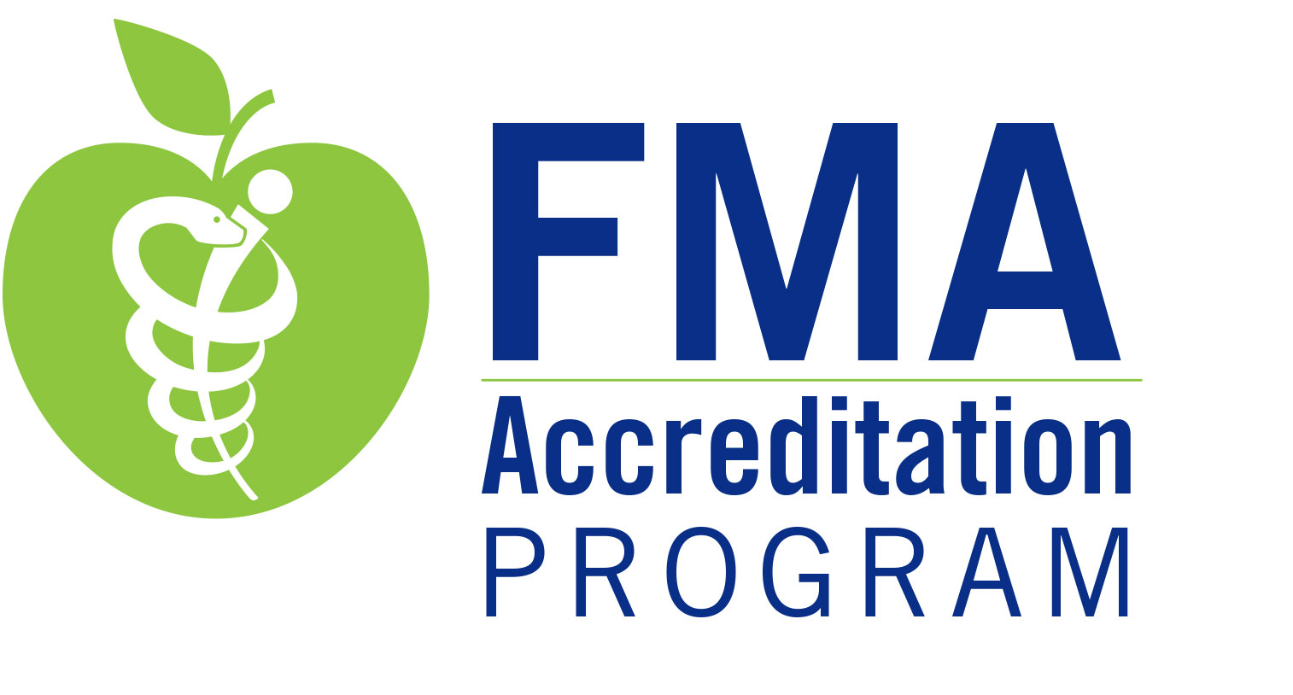

Performance-in-Practice: Structured Abstract & Attachments
Instructions: Complete this form and assemble the attachments for each activity selected for review. Instructions for submission are provided at the end of this document. If your organization does not have evidence to demonstrate that a criterion was met in an activity, explain why there is no evidence in the related gray field provided on the structured abstract. (e.g., missing evidence due to lost files or planning documents, staff turnover, etc.) Note: If Regularly Scheduled Series (RSS) are selected, submit evidence for the series, not just for a single session or a sampling of sessions. The series is the activity. Please do not edit, delete, or modify content in this form.

Name of Organization: |  |  |  |  | Activity Type: | Select from drop-down menu. | Providership: | ☐ Direct  ☐ Joint (specify):
Activity Date: |  |  | Activity Title:

State the professional practice gap(s) of your learners on which the activity was based. (max 100 words) (C2)
State the educational need(s) that you determined to be the cause of the professional practice gap(s). Complete all that apply. (max 50 words each) (C2) |  | Knowledge need
 |  | Competence need
 |  | Performance need
State what this CME activity was designed to change in terms of learners’ competence or performance or patient outcomes. Complete all that apply. (max 50 words) (C3) |  | Competence
 |  | Performance
 |  | Patient Outcomes
Which type of educational format was selected for this activity? (C5)
Explain why this educational format was appropriate for this activity. (max 25 words) (C5)
Indicate the desirable physician attribute(s) (i.e., competencies) this activity addressed. Select all that apply. (C6) | ACGME/ABMS |  |  | ☐ Patient Care and Procedural Skills  ☐ Medical Knowledge  ☐ Practice-based Learning and Improvement |  | ☐ Interpersonal and Communication Skills  ☐ Professionalism  ☐ Systems-based Practice
 | Institute of Medicine |  |  | ☐ Provide Patient-centered Care  ☐ Work in Interdisciplinary Teams  ☐ Employ Evidence-based Practice |  | ☐ Apply Quality Improvement  ☐ Utilize Informatics
 | Interprofessional Education Collaborative |  |  | ☐ Values/Ethics for Interprofessional Practice  ☐ Roles/Responsibilities |  | ☐ Teams and Teamwork  ☐ Interprofessional Communication
 | Other Competency(s) (specify):

Individuals in Control of Content
Did any individuals in control of content refuse to disclose? (C7 SCS 2.2) | ☐ Yes ☐ No

For each individual in control of content, list the name of the individual, select the individual’s role(s) in the activity, and indicate if the individual has no relevant financial relationships; or if the individual has relevant financial relationship(s) — the name of the ACCME-defined commercial interest(s) with which the individual has a relevant financial relationship(s), the nature of that relationship(s), and how the conflict(s) was resolved. Note: For an RSS, list individuals for the entire series, not for a single session or a sampling of sessions. (C7 SCS 2.1, 2.2, 2.3). If you need additional rows — right click on the last row in the table, select Insert, then select Insert Rows Below.
Name of individual | Individual’s role(s) |  |  |  |  |  | Check here if no relevant financial relationships | Complete this section if the individual has a relevant financial relationship(s) with an ACCME-defined commercial interest
 | Course Director | Reviewer/  CME Comm | Planner | Moderator | Presenter/ Author | Patient/  Other |  | Name of commercial interest(s) | Nature of relationship(s) | Mechanism(s) implemented to resolve conflict of interest in the activity

Did the table above include an employee(s) or owner(s) of an ACCME-defined commercial interest(s)? | ☐ Yes (if yes, complete the section directly below)  ☐ No (go to the next section — Commercial Support)

Did their participation meet one of the three specific circumstances permitted by the ACCME? (C7 SCS 1.1) | ☐ Yes (if yes, select which circumstance(s) was met below and describe how you ensured independence of the activity)  ☐ No

 | ☐ | Content of the activity was not related to the business lines or products of their employer.
 | ☐ | Content was limited to basic science research (e.g., pre-clinical research, drug discovery) or the processes/methodologies of research, themselves unrelated to a specific disease or compound/drug.
 |  | Describe processes implemented to ensure that the individual(s) had no control over the content that was related to clinical applications of the research/discovery or clinical recommendations concerning the business lines or products of their employer.
☐ |  | Participated as technicians that teach the safe and proper use of medical devices.
 |  | Describe processes implemented to ensure that the individual(s) had no control over the content that was related to clinical recommendations concerning the business lines or products of their employer.

Commercial Support
Did the activity receive commercial support? | ☐ Yes (if yes, complete the section below)  ☐ No
List the names of the commercial supporters of this activity and the $ value of any monetary commercial support and/or indicate in-kind support. (C8 SCS 3.4-3.6) If you need additional rows — right click on the last row in the table, select Insert, then select Insert Rows Below.
Name of commercial supporter |  | Amount of monetary commercial support | In-kind
 |  |  | ☐
 |  |  | ☐

Attachments

Instructions: Assemble and label each attachment with the appropriate number. Include Attachments 1-6 in ALL activity files selected for review. If evidence is not available related to an attachment, write or type on a sheet of paper in place of the attachment, the attachment # and why there is no evidence. For example, “Attachment 2 — no evidence because it cannot be found or it was not documented” or “Attachment 3 – no conflicts to resolve”. If Attachment 1 includes the information requested in Attachment 6, you can label the first attachment – “Attachment 1 & 6”.

Attachment 1 | Evidence of the activity topics/content (e.g., agenda, brochure, program book, announcement, etc.).  For RSS: include evidence for all sessions — if the series was topic-based such as a grand rounds series, provide a list of the dates and topics of each session or attach documentation (e.g. flyer, announcement, etc.) for each session within the series. (C10, CME Clinical Content Validation Policy, ACCME Definition of CME)
Attachment 2 | Completed form(s), tool(s), or mechanism(s) from the activity used to identify relevant financial relationships of individuals in control of content — attach an example for a planner/reviewer and an example for a faculty member (speaker, author, etc.). (C7 SCS 2.1)
Attachment 3 | If applicable, the completed form(s), tool(s), or mechanism(s) used to resolve conflicts of interest. Attach evidence of resolution for ALL individuals that indicated a relevant financial relationship.  For RSS: attach evidence of resolution for all sessions for ALL individuals that indicated a relevant financial relationship. (C7 SCS 2.3)
Attachment 4 | Evidence (e.g. flyer, slide, brochure, verbal documentation, etc.) from the activity of the disclosure information presented to learners, about presence or absence of relevant financial relationships for ALL individuals in control of content.  For RSS: include evidence for all sessions. (C7 SCS 6.1-6.2, 6.5)
Attachment 5 | The data or information generated from this activity about changes achieved in learners’ competence or performance or patient outcomes. Include data or information in support of what you reported you would measure in PARS for the activity. If you use evaluation forms, do not submit each individual form, compile the data into one form or submit a summary of the changes related to competence, performance or patient outcomes.  For RSS: include data or information for entire series. (C11)
Attachment 6 | Evidence (e.g., flyer, brochure, announcement, etc.) from the activity of the FMA accreditation statement for this activity, as provided to learners.

If the activity was commercially supported, include Attachments 7-9, otherwise, omit this section.
Attachment 7 | The income and expense statement for this activity that itemizes the source(s) of commercial support and details the receipt and expenditure of all the commercial support. (C8 SCS 3.13)
Attachment 8 | Each executed commercial support agreement for the activity. (C8 SCS 3.4-3.6)
Attachment 9 | Evidence from the activity of the commercial support disclosure information as presented to learners. (C7 SCS 6.3-6.5)

If the activity is an enduring material, an internet enduring material, or journal-based CME, include Attachment 10, otherwise, omit this section.
Attachment 10 | If the activity was/is available on the internet, please provide a direct link or URL and, if necessary, a generic username and password to login, OR include the CME product in its entirety (screenshots, PDF) if not available via internet.

Instructions for submitting completed forms and attachments:
On-site survey: Organizations are expected to email one copy of the completed Performance-in-Practice Structured Abstracts with attachments for each activity two weeks before the date of the survey. In addition, organizations are expected to have available at the site survey one copy of the completed Performance-in-Practice Structured Abstracts with attachments for each activity.
Virtual survey: Organizations are expected to email one copy of the completed Performance-in-Practice Structured Abstracts with attachments for each activity two weeks before the date of the virtual survey.

Materials may be emailed to Melissa Carter at mcarter@flmedical.org and Chandra Prine at cprine@flmedical.org
The FMA has a e file sharing service that can be utilized to email large files. Call us at 800.762.0233 to discuss this option.

